The CJ socket is a user adjustable socket. It is essential the socket is applied properly for safe function. Please review these instructions with your prosthetist. Your socket should not cause any abnormal pain or skin irritations. Do not hesitate to call with any questions or report any issues that may arise.
- Apply your clean gel liner over clean skin in the normal manner. Make sure to eliminate any trapped air and avoid stretching the gel. (Fig. #1)
- A sock may be applied for comfort. Socks can also be used as an adjunct to the closure adjustment. Make sure the Velcro strap is exposed and oriented properly.
- Loosen the Velcro straps on the socket sail to maximize the socket opening. (Fig. #2)
- Don the socket fully, ensuring full distal contact in the socket. The sail may require being pulled up to proper postion. The flexible sail material can be designed higher than traditional sockets (up to 1” proximal to MPT). This is often advantageous for greater AP control and should not reduce knee flexion. (Fig. #3)
- Prior to tensioning the sail straps, it is often helpful to extend the knee and push the rigid socket firmly against the residual limb to eliminate any gapping. (Fig. #4)
- Tension the sail straps while seated. Take care to tension the straps evenly and not to rotate the socket. It’s often best to re-tension the straps several times working up and down to create an even and comfortable tension. (Fig. #5)
- Remember that your residual limb volume can change quickly (sometimes after only a few steps) and require re-tensioning the sail to compensate for the lost volume and maintain proper socket function. (Figs. #6)
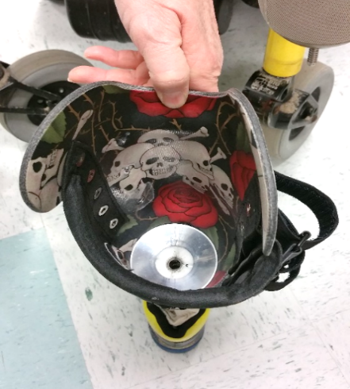
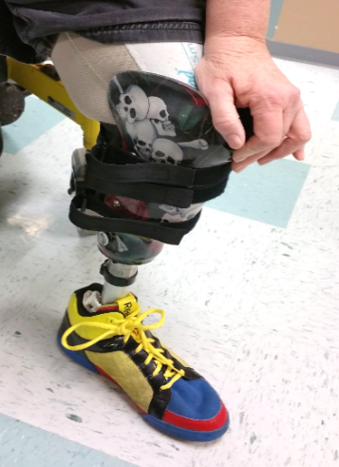

Fig. #2
Fig. #1
Fig. #3
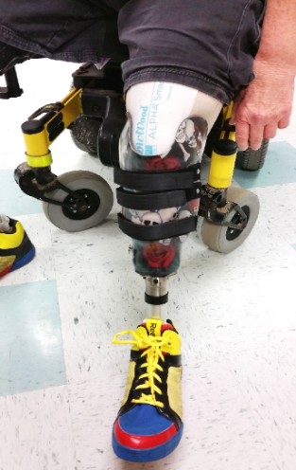
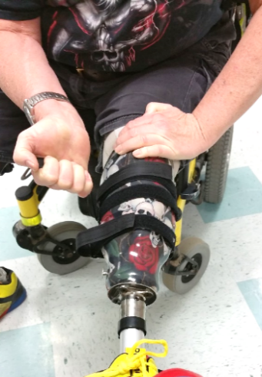
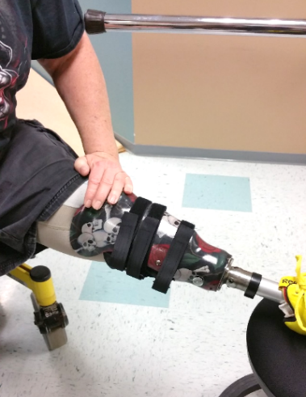

Fig. #5
Fig. #4
Figs. #6
Fig.#5
Fig. #1

