Overview:
Your CJ Sail comes complete with all installation hardware, Patient Instructions, L5999 Description and a Measurement Form. The sail is installed onto the inner surface of the rigid “J” socket.

Preparation:
Place the rigid “J” socket proximal side up and clamp the lateral edge of the sail onto the inner surface of the lateral edge. (Fig 1) Using the premade holes in the sail as a template, mark the corresponding holes on the rigid “J” socket. (Fig 2) Release the clamp and follow the same procedure for the medial side making sure to have the sail extend past the socket trim line proximally. (Fig 3)
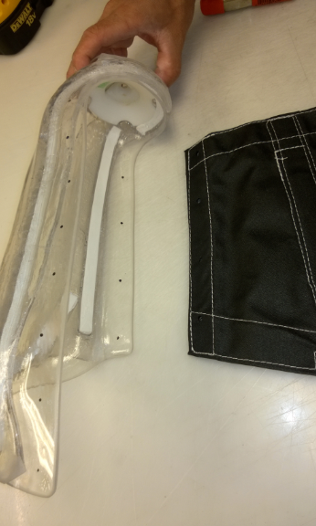
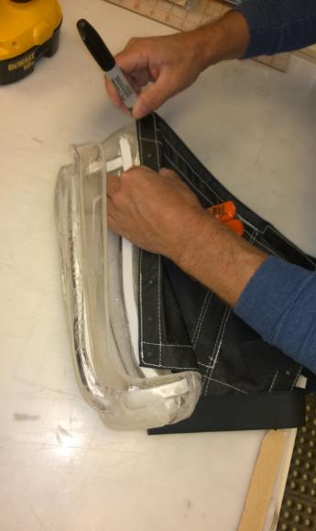
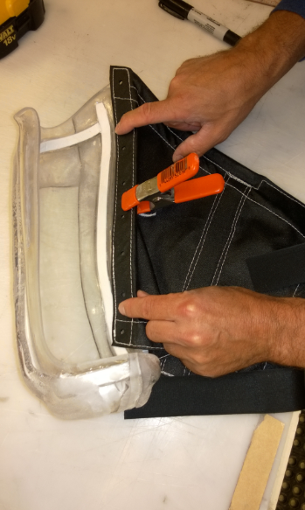

Fig. 2
Fig. 3
Fig. 1

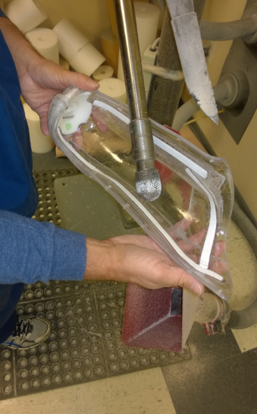
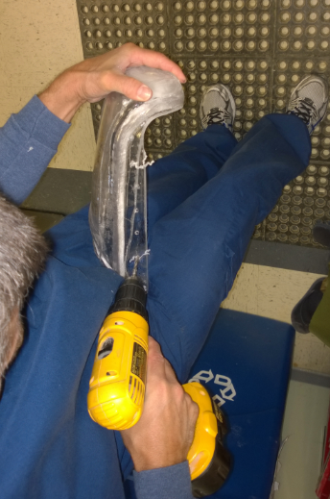

Use a #8 drill to create the hardware holes in the rigid “J” socket. (Fig 4) A burr or a countersink can be used on the inner surface of the hardware holes to create a hollow that will allow the T- nut flange to lie flush or slightly deeper accommodating both the T-nut and Sail thickness. This also serves to spread the strain on the fabric to the largest surface area. (Fig 5)

Fig. 5
Fig. 4

Then use a Dremel or knife to clean the holes of residual plastic. (Fig 6) Install the T-nuts so the flange is on the inside of the Sail and rigid “J’ socket. (Fig 7) Push the T-nut barrel through the Sail and socket. The Barrel should not protrude past the outer surface of the socket. The 8-32 screws included in your Sail shipment should be long enough to accommodate most socket thicknesses to engage the T-nut and not protrude past the T-nut flange on the inside of the socket. The screws must be quite snug (a strong hand tight) to compress the Sail and avoid tearing around the 8-32 threads. You can often see the “star” impression of the t-nut as it compresses the fabric. Attach the medial side of the Sail in the same fashion. The adhesive backed Velcro should be installed over the anterior socket surface so that it lays flat and horizontal. (Fig 8) A low profile speedy rivet is usually installed at the lateral end to prevent the adhesive Velcro from peeling back over time.
Fig. 7
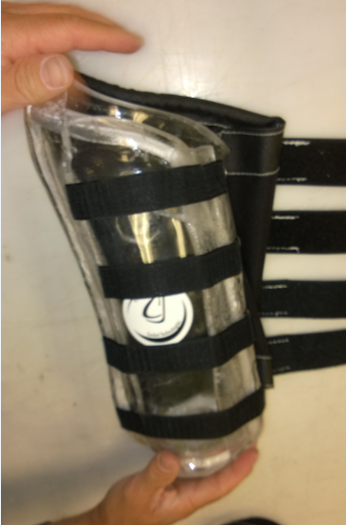
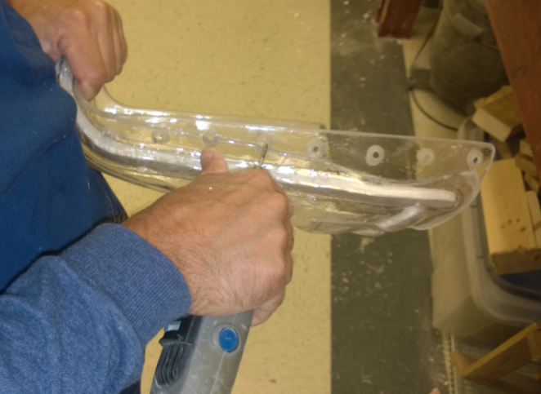
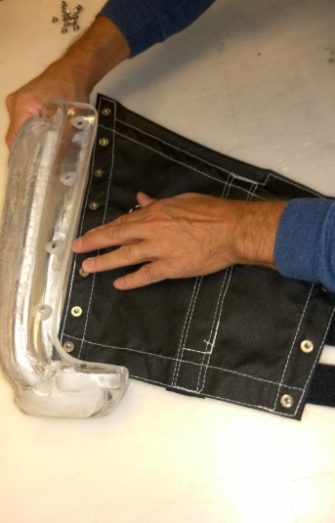

Fig. 6
Fig. 8
Fig. 7
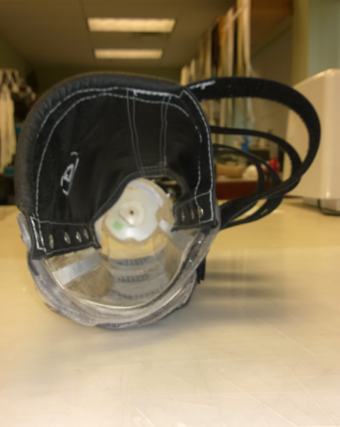
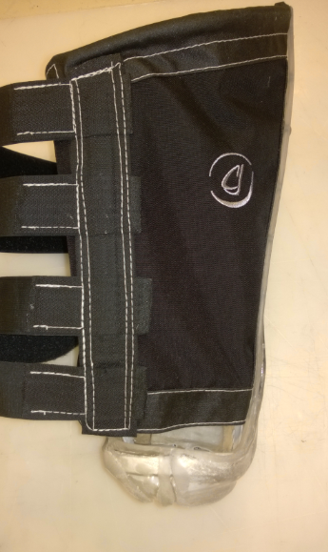

Images showing Sail installed on inner surface of rigid “J” socket.
(Figs. 9 and 10)

Fig. 9
Fig. 10

