The CJ socket is a user volume adjustable socket. It is essential the socket is applied properly for safe function. Please review these instructions with your prosthetist. Your socket should not cause any abnormal pain or skin irritations. Do not hesitate to call with any questions or report any issues that may arise.
- Apply your clean gel liner over clean skin in the normal manner. Make sure to eliminate any trapped air and avoid stretching the gel. The gel should extend to the groin and minimize any exposed skin.
(Fig. #1)
- A sock may be applied for comfort. It can also be used to adjust the fit. Make sure the Velcro strap is exposed and oriented properly. (Fig. #2)
- Loosen the Velcro straps on the socket sail to maximize the socket opening. (Fig. #3)
- Insert the Attachment Strap through the opening at the bottom of the socket and pull the socket on fully. Make sure the bottom of the socket is in contact with the bottom of the gel insert and fasten the Attachment strap snugly. (Figs. # and 5)
- Pull sock over top edge of socket to protect the skin from the plastic socket. (Fig.#6)
- Make sure the Sail’s top edge is pulled up as high as possible and the socket is rotated properly and not gapping in front. Tighten the closure straps for a comfortable secure fit (avoid pulling too tight). It is usually best to begin with the middle straps and work your way to the top and bottom. Check that all straps are snug and comfortable. This may require readjusting the straps. (Fig.#7)
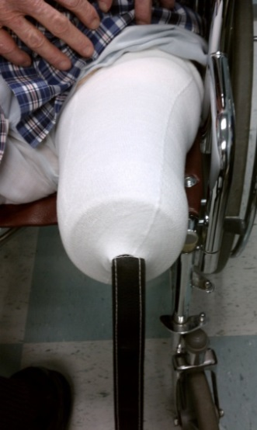
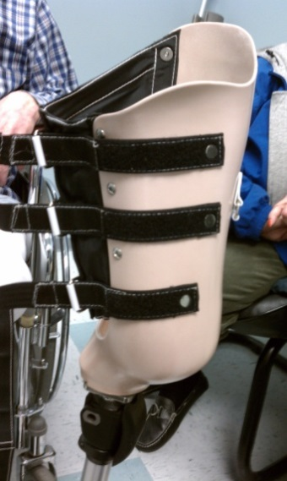
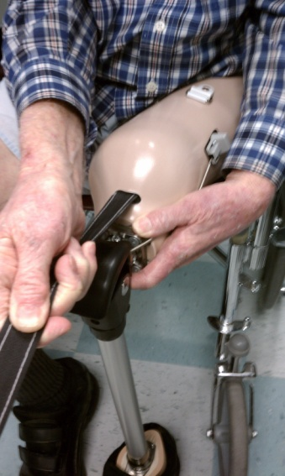

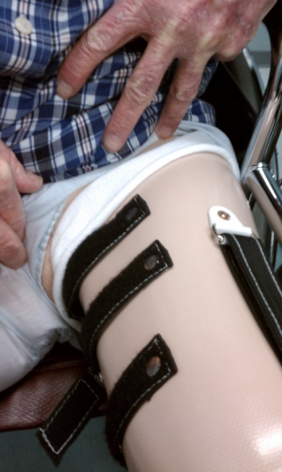
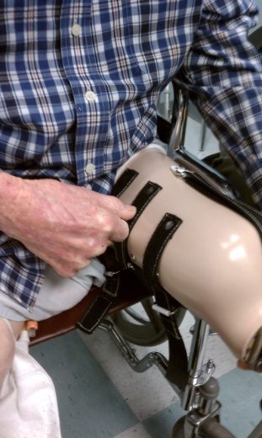
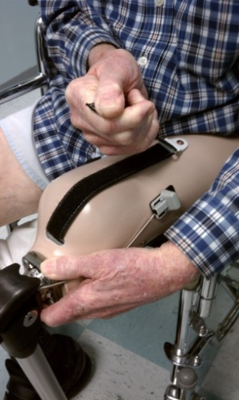
Fig. #6
Fig. #3
Fig. #7
Fig.#5
Push the socket down and inward while pulling straps to avoid gapping and ensure good weight bearing.
Fig. #4
Fig. #2
Fig. #1

